*Highlighted part is either note to internal team or content that needs to be replaced with correct values e.g. email addresses, dates, etc.*

Below is a complete Cookie Policy draft for SproutSong / SproutMentors, including a website-ready opt-in / opt-out banner, consent categories, technical storage mechanism, and React implementation sample.

Your internal DPDP readiness guide specifically lists a Cookie Policy as required if tracking/cookies are used, and also says analytics/tracking requires disclosure and consent where applicable.

---

SproutSong / SproutMentors

Cookie Policy

Internal Review Draft for Compliance Tracking & Website Publication

Document Name: Cookie Policy
Platform: SproutSong / SproutMentors
Version: v1.0 Draft
Prepared For: Internal Review, DPDP Compliance Tracking, Website Publication
Status: Draft — Legal Review Pending
Effective Date: To be added
Last Updated: To be added
Privacy Contact: privacy@sproutsong.com
Support Contact: support@sproutsong.com

---

Internal Review Checklist

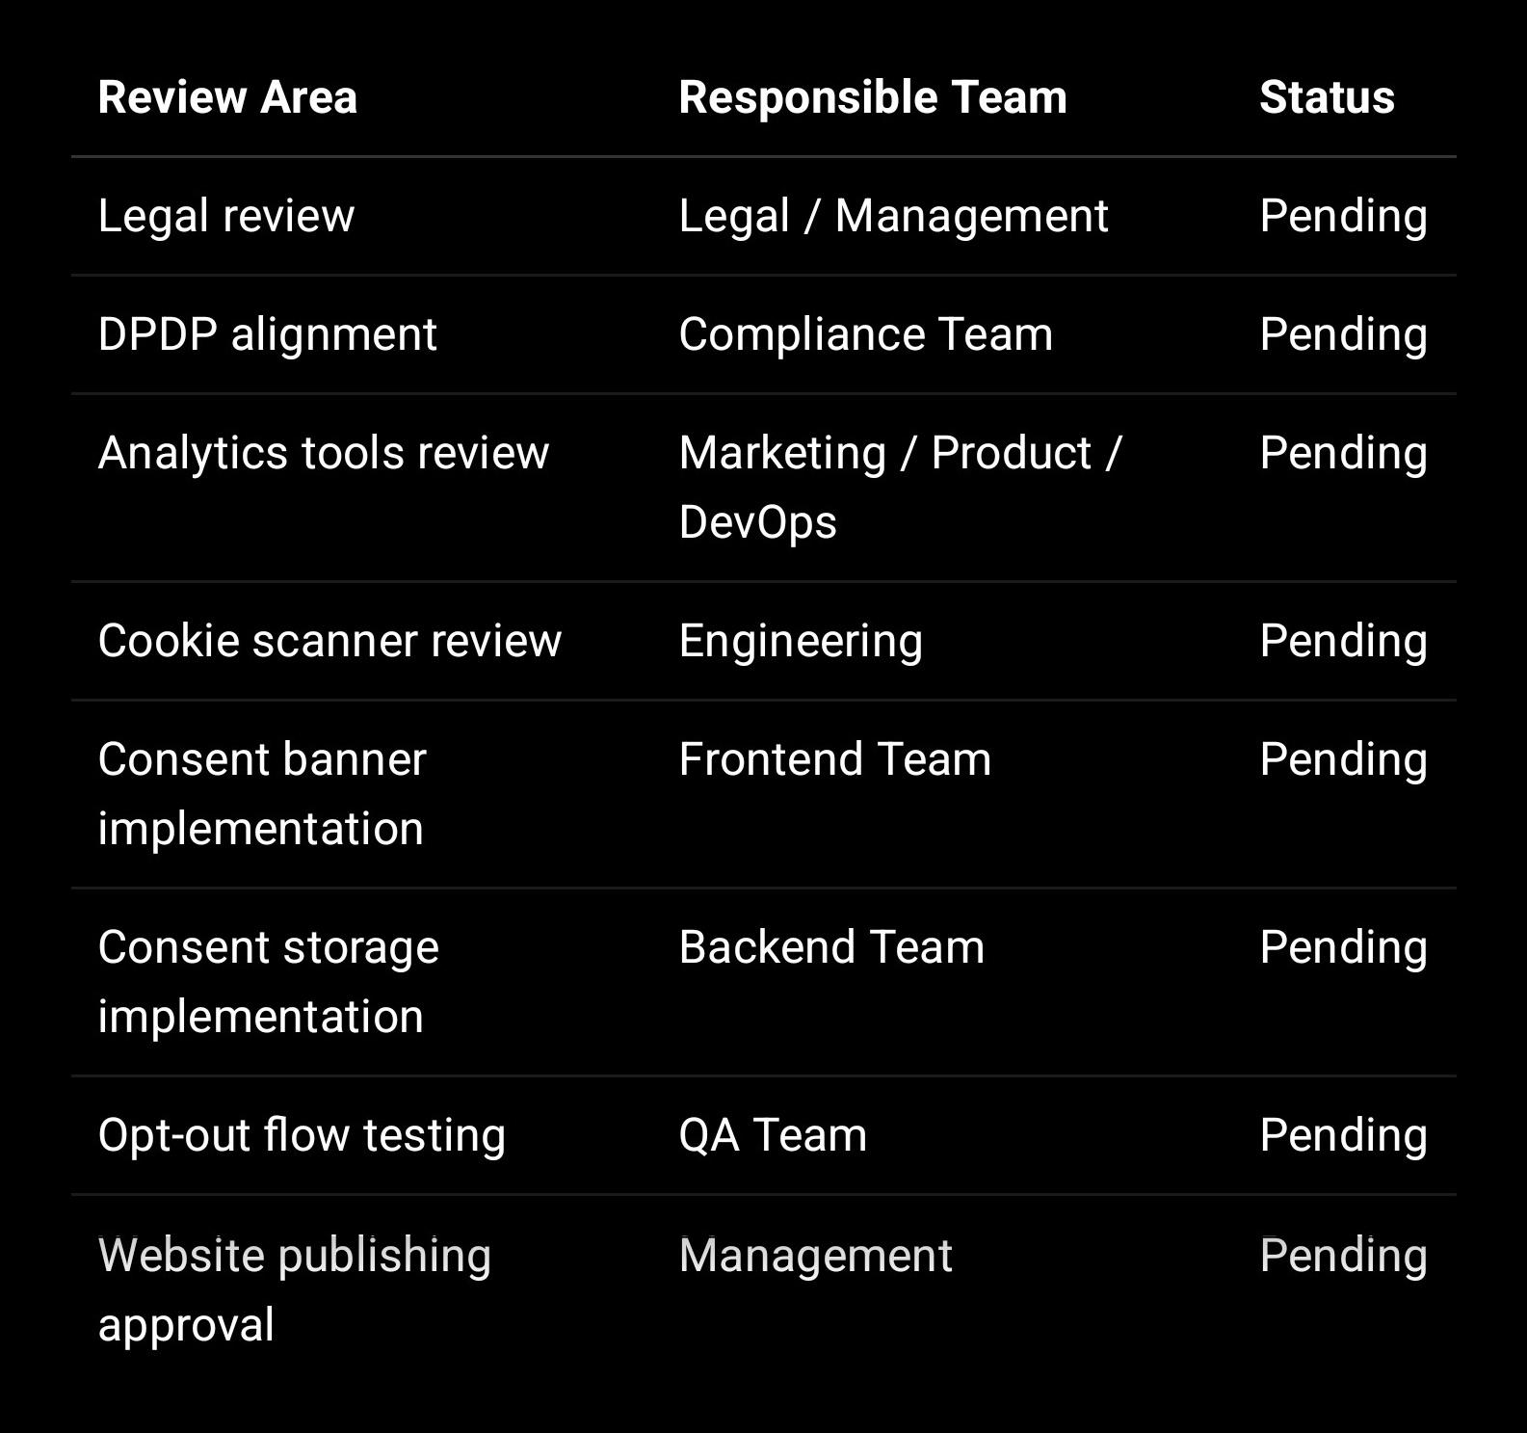

---

1. Purpose of This Cookie Policy

This Cookie Policy explains how SproutSong / SproutMentors uses cookies and similar technologies on its websites, web applications, portals, dashboards, forms, and digital services.

Cookies may be used for:

Login sessions
Security
Remembering user preferences
Analytics
Performance monitoring
Form protection
User experience improvements
Marketing or communication tracking, where enabled

Because SproutSong works with schools, students, parents, teachers, counsellors, and children’s data, cookies and analytics must be used carefully, transparently, and only where necessary or consented.

---

2. What Are Cookies?

Cookies are small text files stored on a user’s browser or device when they visit a website or use a web application.

Cookies can help the platform:

Keep users logged in securely
Protect against fraud or abuse
Remember user preferences
Understand platform usage
Improve performance
Measure website traffic
Support communication or marketing preferences

Cookies may be set by SproutSong directly or by approved third-party tools such as analytics, security, hosting, communication, or monitoring providers.

---

3. Types of Cookies Used

3.1 Strictly Necessary Cookies

These cookies are required for the platform to work.

Examples:

Login session cookie
CSRF/security token
Consent preference cookie
Language or basic accessibility preference
Load-balancing/session routing cookie

These cookies do not require opt-in because they are essential for platform functionality and security.

Example:

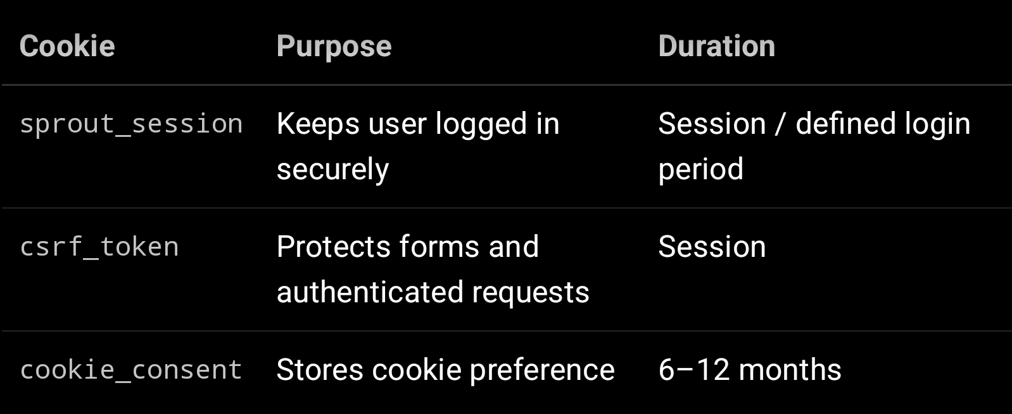

---

3.2 Analytics Cookies

These cookies help SproutSong understand how users use the website or platform.

Examples:

Page visits
Most used pages
Session duration
Device/browser type
Traffic source
Feature usage

Analytics cookies should be optional and should load only after the user agrees.

Your internal DPDP guide lists analytics providers as third-party processors and says the team must identify which third-party services receive SproutSong data.

Example tools:

Google Analytics
Plausible
Microsoft Clarity
Internal analytics
Server-side analytics

Recommended rule:

Do not load analytics scripts until user has selected “Accept Analytics” or “Accept All”.

---

3.3 Performance and Monitoring Cookies

These may help identify technical issues, errors, performance bottlenecks, or uptime problems.

Examples:

Error monitoring
Page speed tracking
API failure tracking
Crash reporting

These should be configured with PII masking and should not capture student names, parent contact details, counselling notes, reports, tokens, passwords, or full request bodies.

Your secure logging guide warns that PII in logs, tokens in logs, passwords in logs, stack traces, Aadhaar, counselling notes, and cross-school data in logs can become breach vectors.

---

3.4 Preference Cookies

These remember user choices.

Examples:

Language
Theme
Font size
Accessibility preference
Cookie preference
Dashboard layout preference

These are usually low-risk, but they should still be disclosed.

---

3.5 Marketing / Communication Cookies

These may be used for:

Campaign tracking
Newsletter conversion tracking
Ad performance tracking
Workshop campaign tracking
Remarketing

For SproutSong, marketing cookies should be off by default and should require explicit opt-in.

Important rule:

Do not use behavioural advertising or targeted advertising cookies for children/students.

Your internal guidance clearly states that children’s data should not be used for targeted advertising or ad profiling based on student behaviour.

---

4. Cookies We Should Not Use for Students

SproutSong should not use cookies or tracking to:

Track children for advertising
Create behavioural ad profiles
Sell or share student browsing behaviour
Target students with commercial ads
Infer sensitive attributes
Track private counselling activity for marketing
Use student report/AI/counselling activity for advertising

This is especially important for student portals, parent portals, counselling forms, AI reports, and marksheet upload flows.

---

5. Where Cookies May Be Used

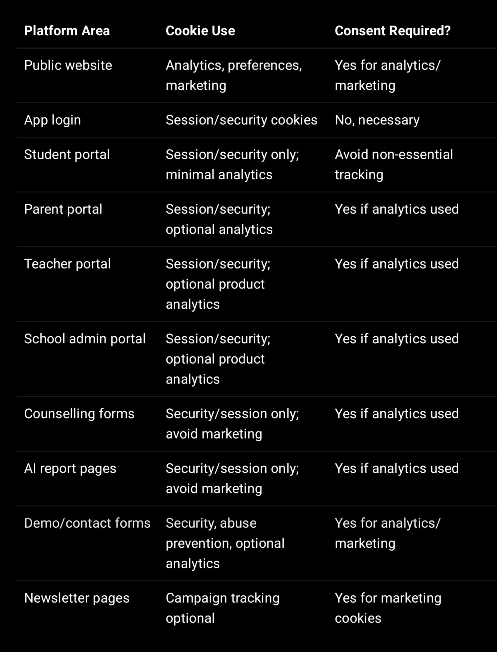

---

6. What Data May Be Collected Through Cookies

Depending on cookie category, SproutSong may collect:

IP address or masked IP
Browser type
Device type
Operating system
Page URL
Time of visit
Referrer source
Session ID
Login/session status
Cookie preference
Approximate location, if analytics tool provides it
Campaign source, if marketing tracking is enabled

SproutSong should avoid collecting through cookies:

Student names
Parent names
Phone numbers
Email addresses
Student reports
Counselling notes
Uploaded documents
Marksheets
Passwords
OTP
JWT tokens exposed to JavaScript
AI prompts or AI reports
Bank/ID/medical data

The backend security guide recommends using HttpOnly + Secure + SameSite cookies for JWT/session handling and never exposing tokens unnecessarily.

---

7. User Choices

Users should be given these options:

Accept All Cookies
Reject Non-Essential Cookies
Manage Preferences
Save Preferences

Cookie categories should include:

Strictly Necessary — Always On
Analytics — Optional
Performance — Optional
Marketing — Optional
Preferences — Optional or allowed based on choice

---

8. Cookie Banner Text

8.1 Short Banner Text

SproutSong uses cookies to keep the platform secure, remember your preferences, and improve our services. We use optional analytics or marketing cookies only with your consent.

We do not use student data for targeted advertising.

You can accept all cookies, reject non-essential cookies, or manage your preferences.

Buttons:

Accept All
Reject Non-Essential
Manage Preferences

---

8.2 Detailed Banner / Preference Modal Text

Cookie Preferences

Strictly Necessary Cookies
These are required for login, security, form protection, and platform functionality. They cannot be switched off.

Analytics Cookies
These help us understand how visitors use SproutSong so we can improve the website and platform. These are optional.

Performance Cookies
These help us monitor errors, speed, and reliability. These are optional and should not capture personal student data.

Marketing Cookies
These help us measure campaigns, workshops, and communication effectiveness. These are optional and are not used for targeted advertising to students or children.

You can change your preferences at any time.

Buttons:

Save Preferences
Accept All
Reject Non-Essential

---

9. Website Cookie Policy Page Draft

9.1 User-Facing Cookie Policy

SproutSong / SproutMentors Cookie Policy

SproutSong / SproutMentors uses cookies and similar technologies to provide a secure and reliable platform, remember user preferences, understand website usage, and improve our services.

Some cookies are strictly necessary for login, security, and platform functionality. These cookies cannot be disabled because the platform may not work properly without them.

Optional cookies, such as analytics, performance, or marketing cookies, are used only where the user has provided consent.

SproutSong does not use children’s data or student platform activity for targeted advertising.

Users may accept all cookies, reject non-essential cookies, or manage their cookie preferences at any time.

For privacy or cookie-related requests, contact privacy@sproutsong.com.

---

10. Cookie Categories Table

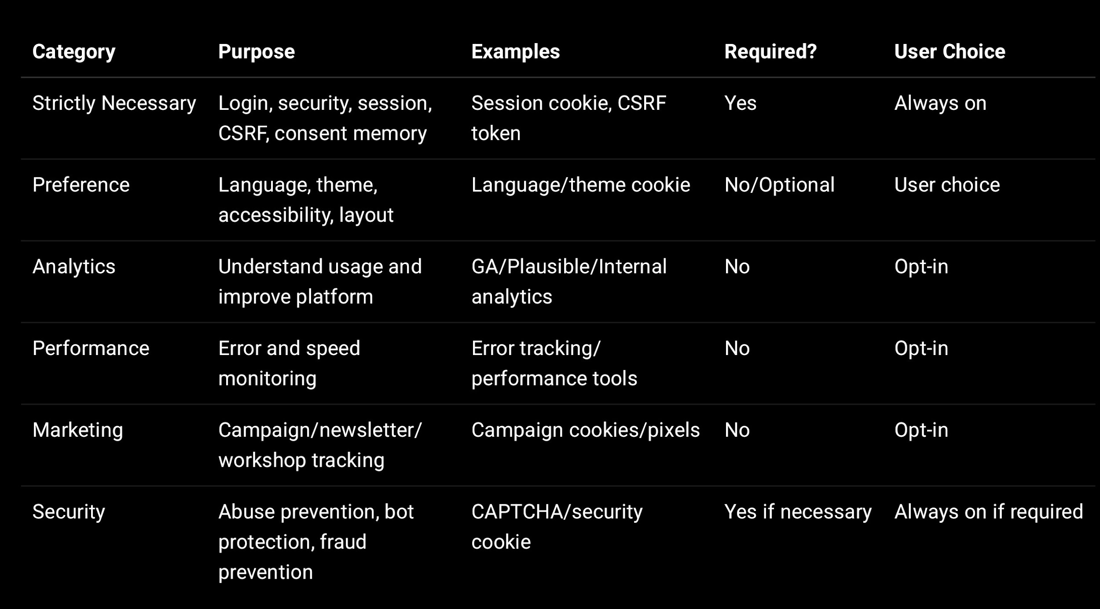

---

11. Consent Storage for Cookies

Cookie consent should be stored both:

1. In browser cookie/local storage for quick frontend decision.

2. In backend database where user is logged in, or where compliance evidence is needed.

For anonymous visitors, store non-PII consent in browser. For logged-in users, store consent in backend linked to user ID.

11.1 Cookie consent object

{
necessary: true,
preferences: true,
analytics: false,
performance: false,
marketing: false,
consentVersion: "cookie-v1.0",
privacyPolicyVersion: "v1.0",
acceptedAt: "2026-05-30T10:30:00.000Z",
source: "WEB_COOKIE_BANNER"
}

11.2 Backend schema

const CookieConsentSchema = new mongoose.Schema({
userId: {
type: mongoose.Schema.Types.ObjectId,
ref: "User",
index: true
},

schoolId: {
type: mongoose.Schema.Types.ObjectId,
ref: "School",
index: true
},

visitorId: {
type: String,
index: true
},

role: {
type: String
},

consentVersion: {
type: String,
required: true
},

privacyPolicyVersion: {
type: String,
required: true
},

necessary: {
type: Boolean,
default: true
},

preferences: {
type: Boolean,
default: false
},

analytics: {
type: Boolean,
default: false
},

performance: {
type: Boolean,
default: false
},

marketing: {
type: Boolean,
default: false
},

action: {
type: String,
enum: ["ACCEPT_ALL", "REJECT_NON_ESSENTIAL", "SAVE_PREFERENCES"],
required: true
},

ipAddressMasked: {
type: String
},

userAgent: {
type: String
},

requestId: {
type: String,
index: true
},

source: {
type: String,
enum: ["WEB_COOKIE_BANNER", "ACCOUNT_SETTINGS", "ADMIN_PANEL"],
default: "WEB_COOKIE_BANNER"
},

agreedAt: {
type: Date,
default: Date.now,
index: true
},

withdrawnAt: Date
}, {
timestamps: true
});

CookieConsentSchema.index({ userId: 1, agreedAt: -1 });
CookieConsentSchema.index({ visitorId: 1, agreedAt: -1 });

The existing forms security guide recommends storing consent proof with fields such as consentGiven, consentTimestamp, consentIP, purpose, source, and policy version for public forms. A similar evidence pattern should be used for cookie consent.

---

12. Frontend Implementation — React Cookie Banner

Below is a simple React component that can be used in the public website or app shell.

import { useEffect, useState } from "react";

const COOKIE_KEY = "sproutsong_cookie_consent";
const CONSENT_VERSION = "cookie-v1.0";
const PRIVACY_VERSION = "privacy-v1.0";

const defaultConsent = {
necessary: true,
preferences: false,
analytics: false,
performance: false,
marketing: false,
consentVersion: CONSENT_VERSION,
privacyPolicyVersion: PRIVACY_VERSION
};

export default function CookieConsentBanner() {
const [visible, setVisible] = useState(false);
const [showSettings, setShowSettings] = useState(false);
const [choices, setChoices] = useState(defaultConsent);

useEffect(() => {
const saved = localStorage.getItem(COOKIE_KEY);

if (!saved) {
setVisible(true);
return;
}

try {
const parsed = JSON.parse(saved);

if (parsed.consentVersion !== CONSENT_VERSION) {
setVisible(true);
} else {
applyCookiePreferences(parsed);
}
} catch {
setVisible(true);
}
}, []);

const saveConsent = async (consent, action) => {
const payload = {
...consent,
necessary: true,
action,
agreedAt: new Date().toISOString(),
source: "WEB_COOKIE_BANNER"
};

localStorage.setItem(COOKIE_KEY, JSON.stringify(payload));
applyCookiePreferences(payload);
setVisible(false);

try {
await fetch("/api/v1/cookie-consent", {
method: "POST",
headers: {
"Content-Type": "application/json"
},
credentials: "include",
body: JSON.stringify(payload)
});
} catch (error) {
// Do not block user experience if consent logging API fails
console.warn("Cookie consent log failed");
}
};

const acceptAll = () => {
saveConsent({
...defaultConsent,
preferences: true,
analytics: true,
performance: true,
marketing: true
}, "ACCEPT_ALL");
};

const rejectNonEssential = () => {
saveConsent(defaultConsent, "REJECT_NON_ESSENTIAL");
};

const savePreferences = () => {
saveConsent(choices, "SAVE_PREFERENCES");
};

if (!visible) return null;

return (
<div className="cookie-banner">
<div className="cookie-card">
<h3>Cookie Preferences</h3>

{!showSettings ? (
<>
<p>
SproutSong uses cookies to keep the platform secure, remember
preferences, and improve our services. Optional analytics and
marketing cookies are used only with your consent. We do not use
student data for targeted advertising.
</p>

<div className="cookie-actions">
<button onClick={acceptAll}>Accept All</button>
<button onClick={rejectNonEssential}>Reject Non-Essential</button>
<button onClick={() => setShowSettings(true)}>
Manage Preferences
</button>
</div>
</>
) : (
<>
<CookieToggle
title="Strictly Necessary Cookies"
description="Required for login, security, form protection, and platform functionality."
checked={true}
disabled={true}
/>

<CookieToggle
title="Preference Cookies"
description="Remember language, theme, and accessibility preferences."
checked={choices.preferences}
onChange={(value) =>
setChoices({ ...choices, preferences: value })
}
/>

<CookieToggle
title="Analytics Cookies"
description="Help us understand website usage and improve the platform."
checked={choices.analytics}
onChange={(value) =>
setChoices({ ...choices, analytics: value })
}
/>

<CookieToggle
title="Performance Cookies"
description="Help us monitor performance, errors, and reliability."
checked={choices.performance}
onChange={(value) =>
setChoices({ ...choices, performance: value })
}
/>

<CookieToggle
title="Marketing Cookies"
description="Help us measure campaigns and workshops. Not used for targeted advertising to students."
checked={choices.marketing}
onChange={(value) =>
setChoices({ ...choices, marketing: value })
}
/>

<div className="cookie-actions">
<button onClick={savePreferences}>Save Preferences</button>
<button onClick={acceptAll}>Accept All</button>
<button onClick={rejectNonEssential}>Reject Non-Essential</button>
</div>
</>
)}

<p className="cookie-links">
<a href="/cookie-policy" target="_blank">Cookie Policy</a>
{" · "}
<a href="/privacy-policy" target="_blank">Privacy Policy</a>
</p>
</div>
</div>
);
}

function CookieToggle({ title, description, checked, disabled, onChange }) {
return (
<label className="cookie-toggle">
<div>
<strong>{title}</strong>
<p>{description}</p>
</div>

<input
type="checkbox"
checked={checked}
disabled={disabled}
onChange={(e) => onChange?.(e.target.checked)}
/>
</label>
);
}

function applyCookiePreferences(consent) {
window.__SPROUT_COOKIE_CONSENT__ = consent;

if (consent.analytics) {
loadAnalyticsScripts();
}

if (consent.performance) {
loadPerformanceScripts();
}

if (consent.marketing) {
loadMarketingScripts();
}
}

function loadAnalyticsScripts() {
// Load Google Analytics / Plausible only after consent
}

function loadPerformanceScripts() {
// Load performance/error tracking only after consent if optional
}

function loadMarketingScripts() {
// Load marketing pixels only after consent
}

---

13. CSS for Banner

.cookie-banner {
position: fixed;
left: 0;
right: 0;
bottom: 0;
z-index: 9999;
padding: 16px;
background: rgba(0, 0, 0, 0.45);
}

.cookie-card {
max-width: 960px;
margin: 0 auto;
background: #ffffff;
border-radius: 14px;
padding: 20px;
box-shadow: 0 10px 35px rgba(0, 0, 0, 0.18);
font-family: system-ui, -apple-system, BlinkMacSystemFont, "Segoe UI", sans-serif;
}

.cookie-card h3 {
margin: 0 0 8px;
font-size: 20px;
}

.cookie-card p {
margin: 0 0 14px;
color: #4b5563;
line-height: 1.55;
}

.cookie-actions {
display: flex;
flex-wrap: wrap;
gap: 10px;
margin-top: 14px;
}

.cookie-actions button {
border: 0;
border-radius: 8px;
padding: 10px 16px;
cursor: pointer;
font-weight: 600;
}

.cookie-actions button:first-child {
background: #1f7a4d;
color: #fff;
}

.cookie-actions button:nth-child(2) {
background: #f3f4f6;
color: #111827;
}

.cookie-actions button:nth-child(3) {
background: #1f2937;
color: #fff;
}

.cookie-toggle {
display: flex;
justify-content: space-between;
gap: 16px;
border: 1px solid #e5e7eb;
border-radius: 10px;
padding: 12px;
margin-bottom: 10px;
}

.cookie-toggle strong {
display: block;
margin-bottom: 4px;
}

.cookie-toggle p {
margin: 0;
font-size: 14px;
}

.cookie-links {
margin-top: 12px !important;
font-size: 14px;
}

.cookie-links a {
color: #1f7a4d;
text-decoration: underline;
}

—

14. Backend API to Store Cookie Consent

const express = require("express");
const router = express.Router();
const crypto = require("crypto");
const CookieConsent = require("../models/CookieConsent");

function maskIp(ip = "") {
if (ip.includes(".")) {
return ip.split(".").slice(0, 3).join(".") + ".0";
}
return ip;
}

function getVisitorId(req, res) {
let visitorId = req.cookies?.sprout_visitor_id;

if (!visitorId) {
visitorId = crypto.randomUUID();

res.cookie("sprout_visitor_id", visitorId, {
httpOnly: true,
secure: process.env.NODE_ENV === "production",
sameSite: "Lax",
maxAge: 365 * 24 * 60 * 60 * 1000
});
}

return visitorId;
}

router.post("/cookie-consent", async (req, res) => {
try {
const allowedActions = [
"ACCEPT_ALL",
"REJECT_NON_ESSENTIAL",
"SAVE_PREFERENCES"
];

if (!allowedActions.includes(req.body.action)) {
return res.status(400).json({
success: false,
message: "Invalid consent action"
});
}

const visitorId = getVisitorId(req, res);

await CookieConsent.create({
userId: req.user?._id || null,
schoolId: req.user?.schoolId || null,
visitorId,
role: req.user?.role || "VISITOR",

consentVersion: req.body.consentVersion || "cookie-v1.0",
privacyPolicyVersion: req.body.privacyPolicyVersion || "privacy-v1.0",

necessary: true,
preferences: Boolean(req.body.preferences),
analytics: Boolean(req.body.analytics),
performance: Boolean(req.body.performance),
marketing: Boolean(req.body.marketing),

action: req.body.action,

ipAddressMasked: maskIp(req.ip),
userAgent: req.headers["user-agent"],
requestId: req.requestId,
source: "WEB_COOKIE_BANNER",
agreedAt: new Date()
});

return res.json({
success: true,
message: "Cookie preference saved"
});
} catch (error) {
return res.status(500).json({
success: false,
message: "Could not save cookie preference"
});
}
});

module.exports = router;

Do not log raw cookie payloads with IP, identifiers, or user-agent unnecessarily. Your secure logging guide recommends masking IP, never logging tokens/cookies, and using structured logs with request IDs instead of raw request bodies.

—

15. Consent Loading Rule for Analytics Scripts

Do not put Google Analytics / marketing scripts directly in <head> if they should depend on opt-in.

Bad:

<script src="https://www.googletagmanager.com/gtag/js?id=G-XXXX"></script>

Better:

function loadGoogleAnalytics() {
if (window.__GA_LOADED__) return;

const script = document.createElement("script");
script.src = "https://www.googletagmanager.com/gtag/js?id=G-XXXX";
script.async = true;
document.head.appendChild(script);

window.dataLayer = window.dataLayer || [];
function gtag(){ window.dataLayer.push(arguments); }
window.gtag = gtag;

gtag("js", new Date());
gtag("config", "G-XXXX", {
anonymize_ip: true
});

window.__GA_LOADED__ = true;
}

Then call only after consent:

if (consent.analytics) {
loadGoogleAnalytics();
}

—

16. Opt-Out Mechanism

Users should be able to change cookie preferences later.

Add footer link:

Cookie Preferences

Clicking it should reopen the preference modal.

Example:

<button onClick={() => window.dispatchEvent(new Event("openCookieSettings"))}>
Cookie Preferences
</button>

Inside banner component:

useEffect(() => {
const open = () => {
setVisible(true);
setShowSettings(true);
};

window.addEventListener("openCookieSettings", open);

return () => {
window.removeEventListener("openCookieSettings", open);
};
}, []);

When user disables analytics/marketing:

const optOut = {
analytics: false,
performance: false,
marketing: false
};

localStorage.setItem(COOKIE_KEY, JSON.stringify(optOut));

For GA, also set:

window[`ga-disable-G-XXXX`] = true;

—

17. Cookie Consent Retention

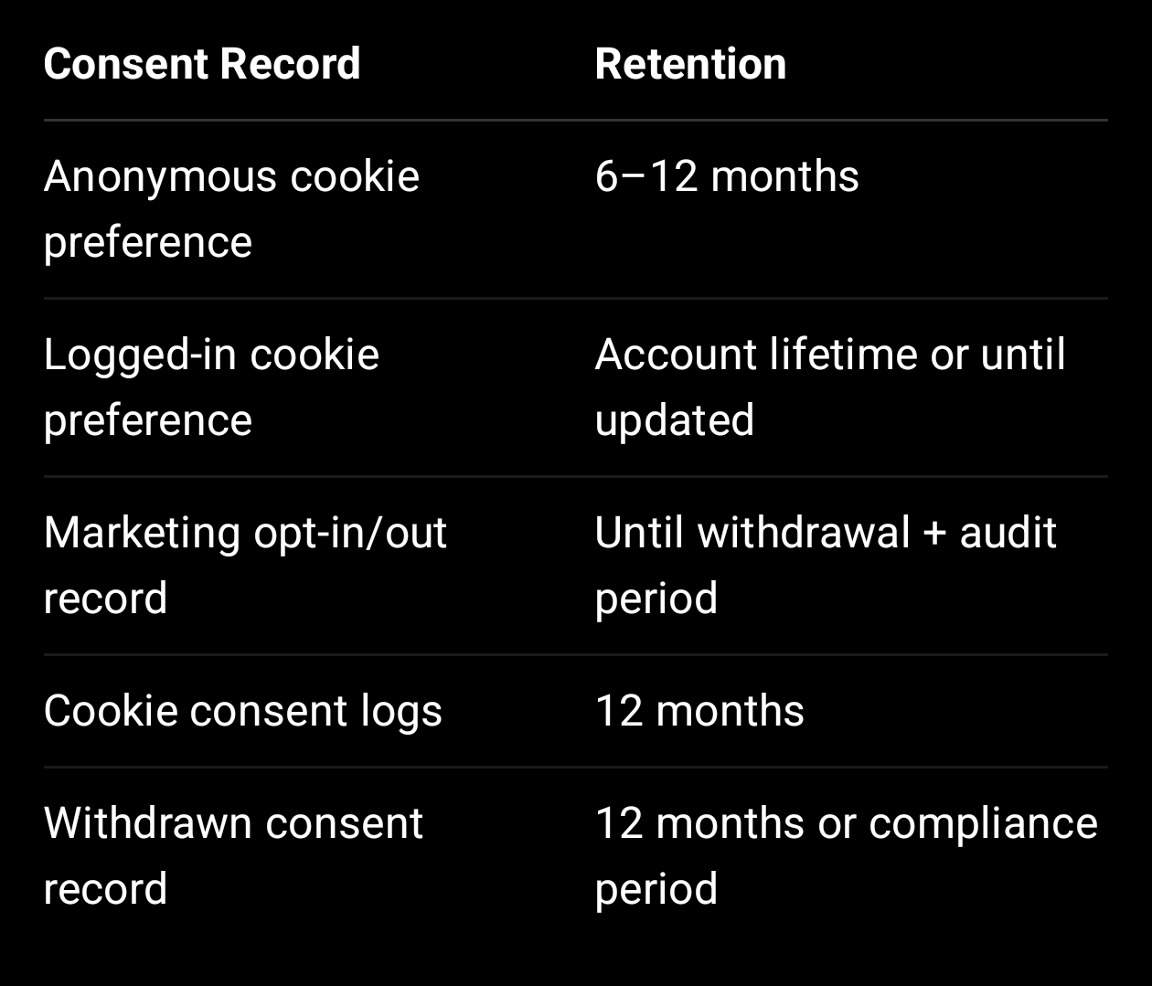
This should align with the Data Retention Policy.

—

18. Cookie Policy for Children / Students

For student portals:

Recommended approach:

Use only necessary cookies by default.
Avoid marketing cookies completely.
Avoid behavioural advertising.
Avoid student-level analytics unless needed and consented.
Use aggregated analytics where possible.
Do not track counselling, reports, AI pages, marksheets, or attendance for marketing.

Student portal cookie message:

This student portal uses essential cookies for login and security. We do not use student activity for targeted advertising. Optional analytics, if enabled by the school/platform, are used only to improve platform performance and are not used to profile students for advertising.

—

19. Security Headers Related to Cookies

Use secure cookie flags:

res.cookie("accessToken", token, {
httpOnly: true,
secure: process.env.NODE_ENV === "production",
sameSite: "Strict",
maxAge: 8 * 60 * 60 * 1000
});

Recommended:

HttpOnly = true for auth cookies
Secure = true in production
SameSite = Strict or Lax
Short expiry
No JWT in localStorage

Your backend security guide recommends JWT stored in HttpOnly + Secure + SameSite=Strict cookies and token invalidation on role changes/password resets.

—

20. Website Footer Link

Add footer links:

Privacy Policy
Terms & Conditions
Child Data Protection Policy
Consent Policy
Data Retention Policy
Cookie Policy
Cookie Preferences

The internal DPDP readiness guide lists Cookie Policy alongside Privacy Policy, Terms, Child Data Protection Policy, Consent Policy, Data Retention Policy, Breach Response Policy, and AI Usage Disclaimer.

—

21. Internal Compliance Tracking Fields

Store the Cookie Policy in your compliance document system:

{
documentType: "COOKIE_POLICY",
version: "v1.0",
title: "SproutSong / SproutMentors Cookie Policy",
status: "PUBLISHED",
effectiveDate: "YYYY-MM-DD",
publishedUrl: "https://www.sproutsong.com/cookie-policy",
approvedBy: "Management / Legal / Compliance",
approvedAt: "YYYY-MM-DDTHH:mm:ssZ",
linkedPrivacyPolicyVersion: "v1.0",
linkedConsentPolicyVersion: "v1.0",
changeSummary: "Initial published version",
createdAt: Date,
updatedAt: Date
}

—

22. Final Implementation Checklist

Before publishing:

- Identify all cookies currently used.
- Identify all third-party scripts.
- Classify cookies: necessary, preference, analytics, performance, marketing.
- Remove unnecessary tracking from student/counselling/AI/report pages.
- Implement banner with accept/reject/manage buttons.
- Keep checkboxes off by default for optional cookies.
- Load analytics/marketing scripts only after consent.
- Store consent in browser and backend where required.
- Add Cookie Preferences link in footer.
- Add Cookie Policy page.
- Add Privacy Policy cross-link.
- Configure secure cookie flags for auth cookies.
- Ensure no cookies/tokens are logged.
- Retest with browser dev tools.
- Re-scan website after implementation.

—

Final Website Banner Copy

We use cookies to keep SproutSong secure, remember preferences, and improve our services. Optional analytics and marketing cookies are used only with your consent. We do not use student data for targeted advertising.

[Accept All] [Reject Non-Essential] [Manage Preferences]

This is the version I recommend placing on the website first.

